Lab 1 Tasks:

Part A:

NOTE THAT WHEN TESTING SOME OF THE QUESTION UTILISE THE SAME (int main(){) that appears at the start.

Question 1

Question 2

Part B:

Question 1

Question 2

Part C:

Question 1:

Question 2:

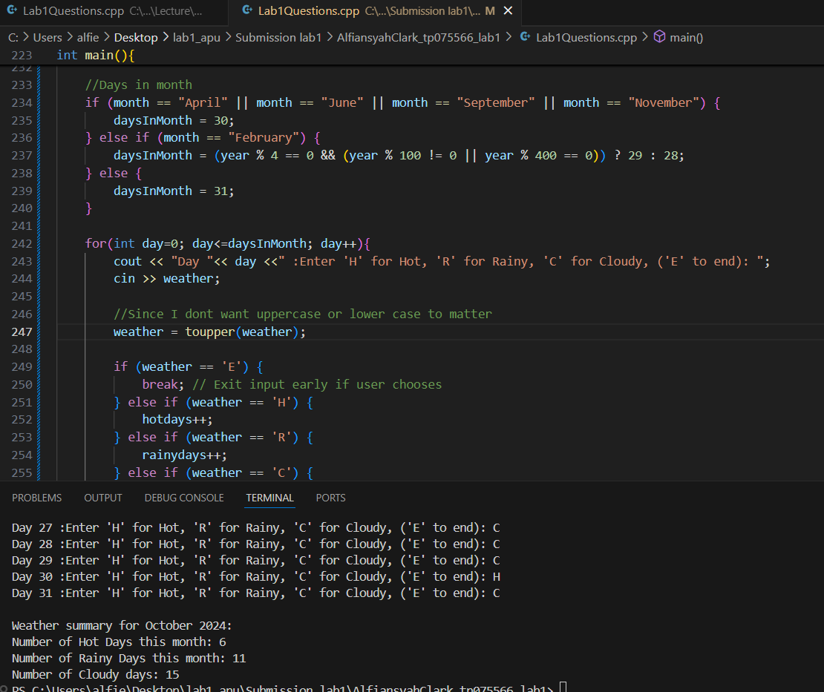

Question 3:

Question 4:

Question 5:

Question 6:

Question 7:

Question 8.

Class Activities:

Activity 1:

Activity 2:

Part 1:

Part 2:

Part 3:

Part 4:

Part 5:

Class Activity 3:

Activity 4:

Activity 5:

